> data()

> view(Nile)

Error in view(Nile) : could not find function "view"

> View(Nile)

> mean(Nile)

[1] 919.35

> sd(Nile)

[1] 169.2275

hist(Nile)

> View(women)

> cor(women)

height weight

height 1.0000000 0.9954948

weight 0.9954948 1.0000000

> cor(womenn$height,women$weight)

Error in is.data.frame(x) : object 'womenn' not found

> cor(women$height,women$weight)

[1] 0.9954948

>

> count_holidays<-c(9,22,11,3,15)

> holiday_type<-c("Regular Holidays", "Bonus Holidays", "Sick Leave", "Casual Leave", "Paid Leave")

> bonus<-c(300,400,500,400,500)

> holidaydata<-data.frame(count_holidays,holiday_type,bonus)

> holidaydata

count_holidays holiday_type bonus

1 9 Regular Holidays 300

2 22 Bonus Holidays 400

3 11 Sick Leave 500

4 3 Casual Leave 400

5 15 Paid Leave 500

>

> boxplot(holidaydata$bonus)

boxplot(holidaydata$count_holidays)

boxplot(holidaydata$count_holidays,holidaydata$bonus)

> index<-c(1,2,3,4,5)

> rain<-c(30,50,70,90,120)

> month<-c('Jan','Feb','Mar','Apr','May')

> rainfall<-data.frame(index,rain,month)

> rainfall

index rain month

1 1 30 Jan

2 2 50 Feb

3 3 70 Mar

4 4 90 Apr

5 5 120 May

> plot(rainfall$rain,type='b')

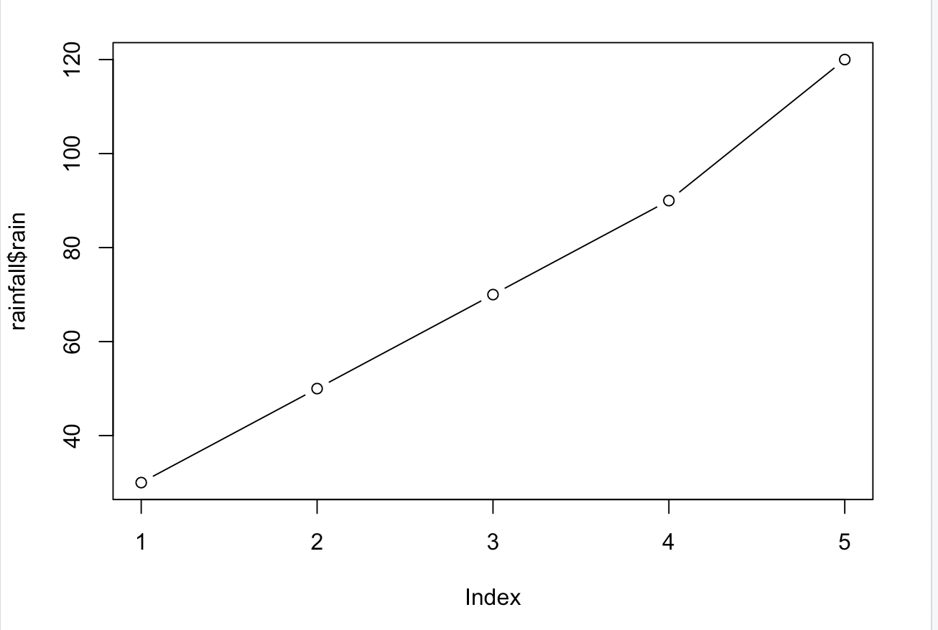

> plot(rainfall$rain,type='b',xlab = 'month',ylab = 'rainfall in cm')

> plot(rainfall$rain,type='b',axes = FALSE,xlab = 'month',ylab = 'rainfall in cm')

> axis(side=1,at=1:length(rain), labels = month)

> axis (side=2)

> box()

> titles(xlab='variable',ylab='value')

Error in titles(xlab = "variable", ylab = "value") :

could not find function "titles"

> title(xlab='variable',ylab='value')

> boxplot(holidaydata$count_holidays,holidaydata$bonus,col = 'aqua marine')

> boxplot(holidaydata$count_holidays,holidaydata$bonus,xlab = 'variable',ylab = 'value', col = 'aquamarine')

> plot(holidaydata$bonus,holidaydata$count_holidays)

> plot(holidaydata$bonus,holidaydata$count_holidays, xlab = 'Bonus',ylab = 'Holiday Count')

>

> data1<-c(200,300,400,500,600)

> month<-c('Jan','Feb','Mar','Apr','May')

> pie(data1, labels = month)

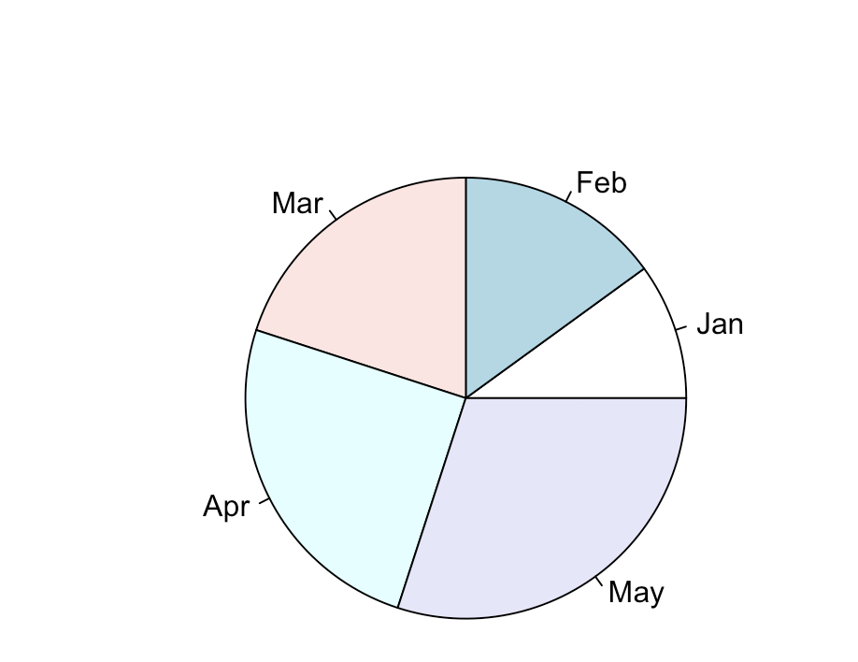

> pc<-c("gray40","gray50","gray60","gray70","gray80")

> pie(data1, labels = month, col=pc)

> pie(data1, labels = month, col=pc, clockwise = TRUE)

